Patterns of C language

Pattern 1.c

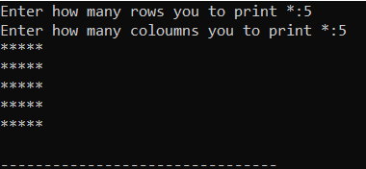

Pattern2.c

patt-2.png

Pattern 3.c

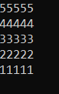

Pattern 4.c

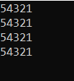

Pattern 5.c

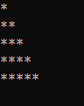

Pattern 6.c

patt-6.png

Pattern 7.c

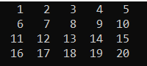

Pattern 8.c

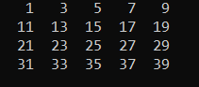

Pattern 9.c

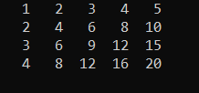

Pattern 10.c

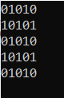

Pattern 11.c

patt-11.png

Pattern 26.c

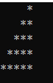

Pattern 13 & 23.c

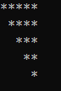

Pattern 14.c

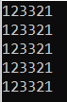

Pattern 15.c

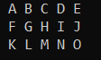

Pattern 16.c

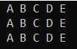

Pattern 17.c

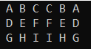

Pattern 41.c

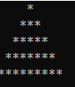

Pattern 19 & 25.c

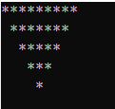

Pattern 20 & 27.c

patt-20.png

Pattern 21 & 28.c

patt-21.png

Pattern 22.c

patt-22.png

Pattern 29.c

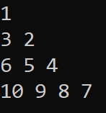

Snack Pattern(horizontal)30.c

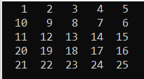

Pattern 31.c

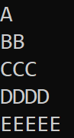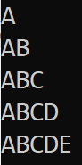

Pattern(vertical) 32 & 33 & 37.c

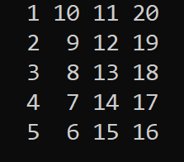

Pattern 34.c

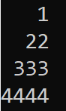

Pattern 35 & 36.c

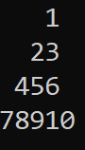

Pattern 38.c

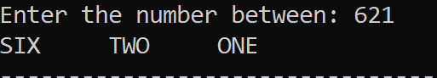

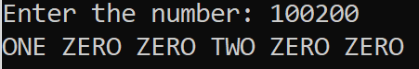

Pattern 39.c

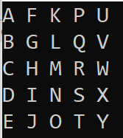

Pattern 40.c

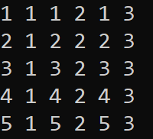

Pattern 24.c

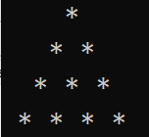

Pattern 42.c

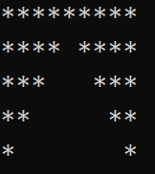

Pattern 43.c

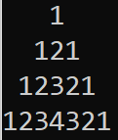

Pattern 44.c

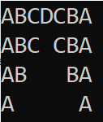

Pattern _diamond.c

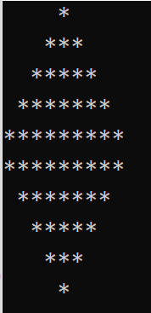

Pattern 45.c

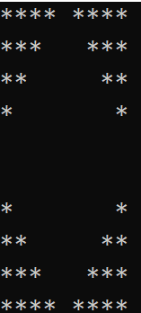

Pattern 46.c

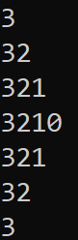

Pattern 47.c

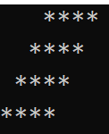

Pattern 48.c

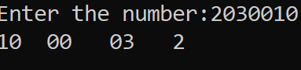

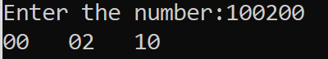

Pattern 49.c

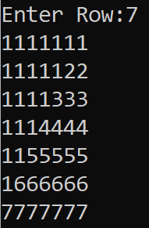

Pattern 50.c

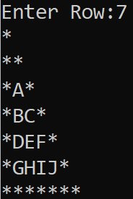

Pattern 51.c

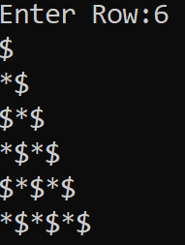

Pattern 52(floyd's triangle).c 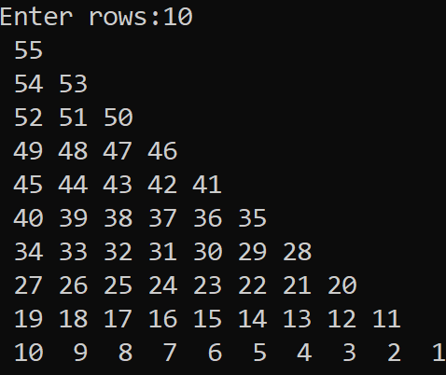

Pattern 53.c

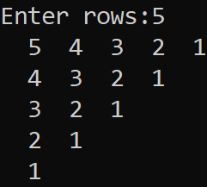

Pattern 54.c

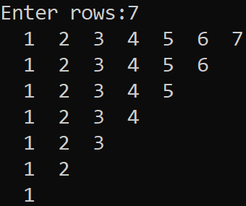

Snack _Pattern 12.c

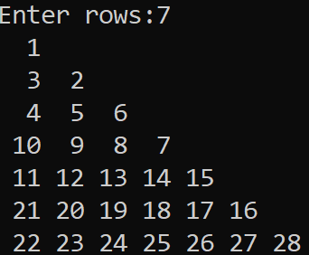

Pattern 18.c

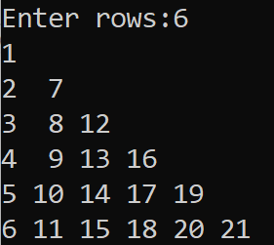

Pattern 55.c

